Case Study: Microsoft Azure | A cloud computing service
What is Azure?
Azure is Microsoft’s cloud platform, just like Google has it’s Google Cloud and Amazon has it’s Amazon Web Service or AWS.000. Generally, it is a platform through which we can use Microsoft’s resource. For example, to set up a huge server, we will require huge investment, effort, physical space and so on. In such situations, Microsoft Azure comes to our rescue. It will provide us with virtual machines, fast processing of data, analytical and monitoring tools and so on to make our work simpler. The pricing of Azure is also simpler and cost-effective. Popularly termed as “Pay As You Go”, which means how much you use, pay only for that.

Azure History
Microsoft unveiled Windows Azure in early October 2008 but it went to live after February 2010. Later in 2014, Microsoft changed its name from Windows Azure to Microsoft Azure. Azure provided a service platform for .NET services, SQL Services, and many Live Services.
Many people were still having doubts about “the cloud”. As an industry, we were entering a brave new world with many possibilities.
Microsoft Azure is getting bigger and better in coming days. More tools and more functionalities are getting added. It has two releases as of now. It’s famous version Microsoft Azure v1 and later Microsoft Azure v2. Microsoft Azure v1 was more like JSON script driven then the new version v2, which has interactive UI for simplification and easy learning. Microsoft Azure v2 is still in the preview version.

How Azure can help in business?
Azure can help in our business in the following ways-

Less Capital: We don’t have to worry about the capital as Azure cuts out the high cost of hardware. You simply pay as you go and enjoy a subscription-based model that’s kind to your cash flow. Also, to set up an Azure account is very easy. You simply register in Azure Portal and select your required subscription and get going.
Less Operational Cost: Azure has low operational cost because it runs on its own servers whose only job is to make the cloud functional and bug-free, it’s usually a whole lot more reliable than your own, on-location server.
Cost Effective: If we set up a server on our own, we need to hire a tech support team to monitor them and make sure things are working fine. Also, there might be a situation where the tech support team is taking too much time to solve the issue incurred in the server. So, in this regard is way too pocket-friendly.
Easy Back Up and Recovery options: Azure keep backups of all your valuable data. In disaster situations, you can recover all your data in a single click without your business getting affected. Cloud-based backup and recovery solutions save time, avoid large up-front investment and roll up third-party expertise as part of the deal.
Easy to implement: It is very easy to implement your business models in Azure. With a couple of on-click activities, you are good to go. Even there are several tutorials to make you learn and deploy faster.
Better Security: Azure provides more security than local servers. Be carefree about your critical data and business applications. As it stays safe in the Azure Cloud. Even, in natural disasters, where the resources can be harmed, Azure is a rescue. The cloud is always on.
Work from anywhere: Azure gives you the freedom to work from anywhere and everywhere. It just requires a network connection and credentials. And with most serious Azure cloud services offering mobile apps, you’re not restricted to which device you’ve got to hand.
Increased collaboration: With Azure, teams can access, edit and share documents anytime, from anywhere. They can work and achieve future goals hand in hand. Another advantage of the Azure is that it preserves records of activity and data. Timestamps are one example of the Azure’s record keeping. Timestamps improve team collaboration by establishing transparency and increasing accountability.
Microsoft Azure Services
Some following are the services of Microsoft Azure offers:

Compute: Includes Virtual Machines, Virtual Machine Scale Sets, Functions for serverless computing, Batch for containerized batch workloads, Service Fabric for microservices and container orchestration, and Cloud Services for building cloud-based apps and APIs.
Networking: With Azure you can use variety of networking tools, like the Virtual Network, which can connect to on-premise data centers; Load Balancer; Application Gateway; VPN Gateway; Azure DNS for domain hosting, Content Delivery Network, Traffic Manager, ExpressRoute dedicated private network fiber connections; and Network Watcher monitoring and diagnostics
Storage: Includes Blob, Queue, File and Disk Storage, as well as a Data Lake Store, Backup and Site Recovery, among others.
Web + Mobile: Creating Web + Mobile applications is very easy as it includes several services for building and deploying applications.
Containers: Azure has a property which includes Container Service, which supports Kubernetes, DC/OS or Docker Swarm, and Container Registry, as well as tools for microservices.
Databases: Azure has also included several SQL-based databases and related tools.
Data + Analytics: Azure has some big data tools like HDInsight for Hadoop Spark, R Server, HBase and Storm clusters
AI + Cognitive Services: With Azure developing applications with artificial intelligence capabilities, like the Computer Vision API, Face API, Bing Web Search, Video Indexer, Language Understanding Intelligent.
Internet of Things(IoT): Includes IoT Hub and IoT Edge services that can be combined with a variety of machine learning, analytics, and communications services.
Security + Identity: Includes Security Center, Azure Active Directory, Key Vault and Multi-Factor Authentication Services.
Developer Tools: Includes cloud development services like Visual Studio Team Services, Azure DevTest Labs, HockeyApp mobile app deployment and monitoring, Xamarin cross-platform mobile development and more.

Difference between AWS (Amazon Web Services), Google Cloud and Azure
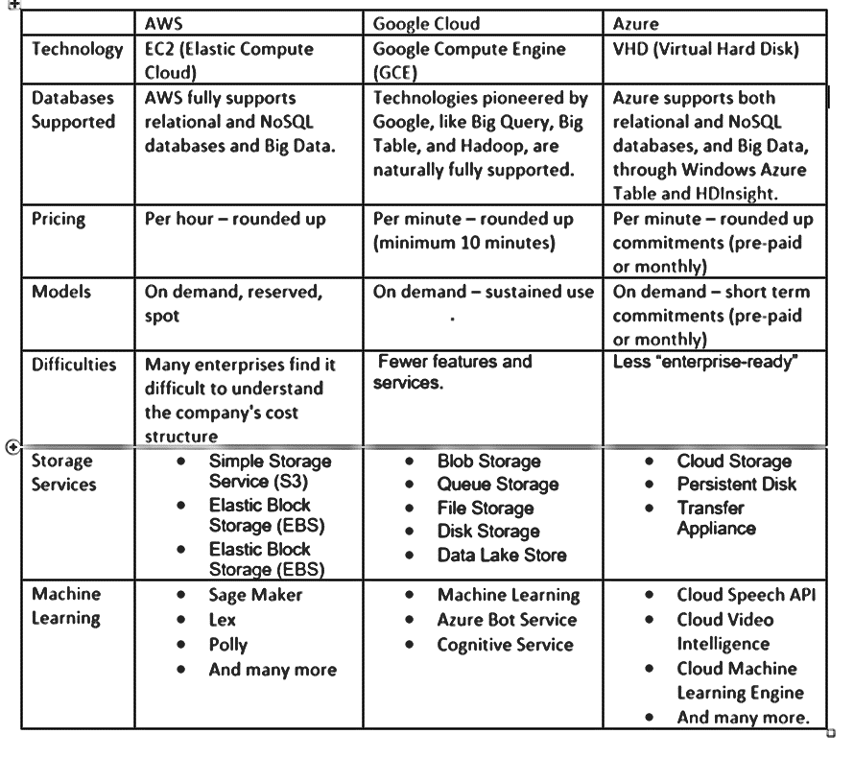

Google App Engine
GAE or Google App Engine or simply known as the App Engine, it is a PAAS or Platform as a Service. It is a cloud computing platform for developing web applications as well as hosting them in data centres managed by Google.
Applications are sandboxed and run across multiple servers. App Engine offers automatic scaling for web applications—as the number of requests increases for an application, App Engine automatically allocates more resources for the web application to handle the additional demand.
Google App Engine primarily supports Go, PHP, Java, Python, Node.js, .NET, and Ruby applications, although it can also support other languages via "custom runtimes".
The Google App Engine allocates more resources automatically to handle additional demands.
The service is free up to a certain level of consumed resources and only in standard environment but not in flexible environment. Fees are charged for additional storage, bandwidth, or instance hours required by the application. It was first released as a preview version in April 2008 and came out of preview in September 2011.

Data storing in scalable web applications can be a real tough job. Google App Engine Datastore uses a superior infrastructure to settle all loads and problems regarding distribution, replication and also load balancing of data. All this is done behind a very simple API and Google App Engine Datastore also provides User a powerful query engine and also transactions.
The Google App Engine Datastore is extremely resilient when it comes to catastrophic failures. It is also consistent, and guarantees a number of safety and security features.
Google has also launched Google App Engine Dashboard which will detail system status for the Google App Engine.
Features of App Engine
1. Runtimes and Languages
User can use Go, Java, PHP or Python to write an app engine application. User can develop and test an app locally using the SDK(software development kit) containing tools for deploying apps. Every language has its own SDK and runtime. User’s code is executed in a:

- Java 7 environment by Java runtime
- Python 2.7 environment by Python runtime
- PHP 5.4 environment by PHP runtime
- Go 1.2 environment by Go runtime

2. Generally Available Features
These are covered by the depreciation policy and the service-level agreement of the app engine. Any changes made to such a feature are backward-compatible and implementation of such a feature is usually stable. These include data storage, retrieval, and search; communications; process management; computation; app configuration and management.

- Data storage, retrieval, and search include features such as HRD migration tool, Google Cloud SQL, logs, datastore, dedicated Memcache, blobstore, Memcache and search.
- Communications include features such as XMPP. channel, URL fetch, mail, and Google Cloud Endpoints.
- Process management includes features like scheduled tasks and task queue.
- Computation includes images.
- App management and configuration cover app identity, users, capabilities, traffic splitting, modules, SSL for custom domains, modules, remote access, and multitenancy.
3. Features in Preview
These features are sure to ultimately become generally available features in some release of the app engine in the future. However, their implementation might change in backward-incompatible ways, as these are in the preview. These include Sockets, MapReduce and Google Cloud Storage Client Library.
Preview features include Google Cloud storage client library, sockets, and MapReduce.
4. Experimental Features
These might or might not become generally available in app engine releases in the future. Their implementation might change in backward-incompatible ways. These are generally available publicly.
However, those mentioned as ‘trusted tester’ are available only to a select user group and they have to sign up to use the features. The experimental features include Appstats Analytics, Restore/Backup/Datastore Admin, Task Queue Tagging, MapReduce, Task Queue REST API, OAuth, Prospective Search, PageSpeed and OpenID.
Experimental features include Appstats analytics, datastore admin/backup/restore, task queue tagging, MapReduce, task queue REST API, OAuth, prospective search, OpenID, and PageSpeed.
5. Third-Party Services
User’s app can do things not built into the core product User know as app engine as Google offers documentation and helper libraries to enhance the capabilities of the app engine platform. Google partners with other organizations to achieve this.
The partners often present special offers for the customers of the app engine besides the helper libraries.
The services include Twilio (voice/SMS) and SendGrid (email).

Advantages of Google App Engine
There are many advantages to the Google App Engine that helps to take User’s app ideas to the next level. This includes:

Infrastructure for Security
Around the world, the Internet infrastructure that Google has is probably the most secure. There is rarely any type of unauthorized access to date as the application data and code are stored in highly secure servers.

User can be sure that User’s app will be available to users worldwide at all times since Google has several hundred servers globally. Google’s security and privacy policies are applicable to the apps developed using Google’s infrastructure.

Faster Time to Market
Quickly releasing a product or service to market is the most important thing for every business. Stimulating the development and maintenance of an app is critical when it comes to deploying the product fast. With the help of Google cloud app Engine, a business can quickly develop-

- Feature-rich apps with a quick development process
- The backend application in a PaaS style environment
- NoSQL style storage, flexible data storage, or Google Cloud SQL for relational database support.
This, further, results in superior quality code, faster time to market, thus offering better customer experience.

Quick to Start
With no product or hardware to purchase and maintain, User can prototype and deploy the app to User’s users without taking much time.

Easy to Use
Google App Engine (GAE) incorporates the tools that User need to develop, test, launch, and update the applications.

Rich set of APIs & Services
Google App Engine has several built-in APIs and services that allow developers to build robust and feature-rich apps. These features include:

- Access to the application log
- Blobstore, serve large data objects
- Google Cloud Storage
- SSL Support
- Page Speed Services
- Google Cloud Endpoint, for mobile application
- URL Fetch API, User API, Memcache API, Channel API, XXMP API, File API
Scalability
For any app’s success, this is among the deciding factors. Google creates its own apps using GFS, Big Table and other such technologies, which are available to User when User utilize the Google app engine to create apps.
User only have to write the code for the app and Google looks after the testing on account of the automatic scaling feature that the app engine has. Regardless of the amount of data or number of users that User’s app stores, the app engine can meet User’s needs by scaling up or down as required.

The good thing about Google App Engine as a manageable platform is that it has made it feasible for our engineers to effortlessly scale up their applications with no-operations skill. It, additionally, sets us up with the best practices as far as logging, security and releasing management is concerned.
Performance and Reliability
Google is among the leaders worldwide among global brands. So, when User discuss performance and reliability User have to keep that in mind. In the past 15 years, the company has created new benchmarks based on its services’ and products’ performance. The app engine provides the same reliability and performance as any other Google product.

Cost Savings
User don’t have to hire engineers to manage User’s servers or to do that User’sself. User can invest the money saved into other parts of User’s business.

Platform Independence
User can move all User’s data to another environment without any difficulty as there are not many dependencies on the app engine platform.

COLLABORATING VIA GROUPWARE
For larger businesses, a social network group probably won’t suffice. What you need instead is a collection of web-based collaborative tools that help your team members not only communicate with each other but also manage their group projects.
This type of solution is commonly known as groupware, and when it’s based in the cloud it’s called online groupware. In a nutshell, groupware is collaboration software for workgroups. Online groupware does away with the physical constraints of traditional groupware, letting members from throughout an organization, in any location, access group assets.
Online groupware typically includes some or all of the following tools:

- File and document uploading and sharing

- Web calendar

- Task/project manager

- Message boards

- Text-based chat rooms / instant messaging

- Wiki-like collaborative pages

- Blogs

Why use online groupware
- First of all, it puts all your group communications (and, in some cases, files) all in one place—and that one place is accessible to group members in any location, as long as they have an Internet connection.
- Second, groupware makes it easier to communicate, which should reduce the number of meetings and conferences calls, as well as your email traffic.
- Finally, all this should increase your group’s collective and members’ individual productivity.

For example, suppose you’re managing a community not-for-profit group. You can use online groupware to connect other managers and volunteers across the community. You can share plans, proposals, and other documents with all members, and use the groupware to solicit and receive proposals and invoices from suppliers. And, best of all, you can do this from your own computer, which means fewer phone calls, car trips, and unnecessary meetings—all of which translates into less time involved and fewer expenses, both of which are important for charities.
List of Most popular online groupware applications.
AirSet
AirSet (www.airset.com) provides a cloud-based website for your group. Your AirSet site can include group announcements, a web calendar, contact list, task list, instant messaging, wiki for collaborative publishing, blog, file sharing and online storage, photo albums, and music playlists. And with all these tools, when one person in the group makes a change, everyone else sees the updated information.

ContactOffice
ContactOffice (www.contactoffice.com) is a web-based data management system that lets you share emails, contacts, tasks, appointments, and documents with other group members. You can create internal or intercompany groups; the latter helps you communicate with customers, suppliers, and other people outside your immediate office. You also get a web-based calendar, address book, message forum, and real-time chat.
Google Sites
Google Sites (sites.google.com), formerly known as Jotspot, lets you create a group web page (hosted by Google). This page is completely customizable with your choice of file uploads, group announcements, task/project management, mailing lists, group calendar, and the like. Google Sites also integrates with Google’s other online apps, including Gmail, Google Calendar, Google Docs, and Google Talk. And, as with most things Google, it’s completely free.
Huddle
Huddle (www.huddle.net) is a hosted environment that combines online collaboration, project management, and document sharing, using social networking principles. You create a network of collaborative team workspaces, managed from a central dashboard. You can then take advantage of Huddle’s online file storage, project calendar, RSS and email notifications, whiteboard, wiki, and other collaborative tools.
Nexo
Nexo (www.nexo.com) lets you create a free personalized group website. The site can include photos, videos, forums, message boards, interactive calendars, polls, and to-do lists. Nexo targets its service to family, friend, and community groups, although it may also function for some less-demanding business groups.
Note: Nexo was recently acquired by Shutterfly.
OpenTeams
OpenTeams (www.openteams.com) is better suited for larger businesses. It offers team folders, blogging, and wiki-like collaborative pages, all monitored via a customizable Navigator page, shown in Figure 4. From here you can keep track of key team members, organize resources with tags, participate in threaded discussions, and monitor new content posted by team members. Pricing is on a per-user, per-use basis.
ProjectSpaces
ProjectSpaces (www.projectspaces.com) provides an online workspace designed especially for group collaboration. You get an online document library, email discussion lists, task management, group announcements via email and RSS, a shared group calendar, and shared group documents.
Teamspace
Our final online groupware application is called teamspace (www.teamspace.com), with a lowercase t. This application offers task and project management, contact management, an online calendar, message forum, notice board, file sharing, text-based chat, and synchronization with Microsoft Outlook. Pricing is on a per-member basis, with additional fees for storage space used.

OpenNebula
- OpenNebula is an open-source toolkit used to build private, public and hybrid clouds. It has been designed to be integrated with networking and storage solutions and to fit into existing data centers.
- The OpenNebula architecture is based on three basic technologies to enable the provision of services on a distributed infrastructure: virtualization, storage and network.
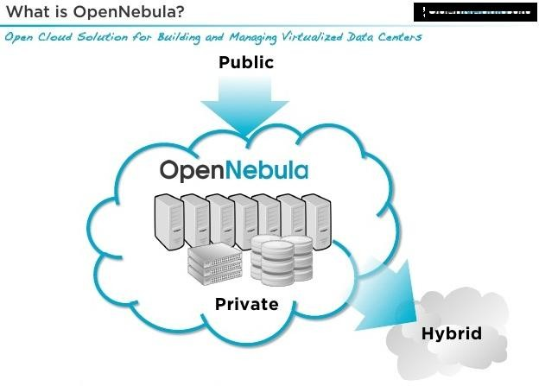

What is the OpenNebula Technology?
OpenNebula provides the most simple but feature-rich and flexible solution for the comprehensive management of virtualized data centers to enable private, public and hybrid IaaS clouds. OpenNebula interoperability makes cloud an evolution by leveraging existing IT assets, protecting your investments, and avoiding vendor lock-in.
OpenNebula is a turnkey enterprise-ready solution that includes all the features needed to provide an on-premises (private) cloud offering, and to offer public cloud services.

Which Functionality Does OpenNebula Provide?

OpenNebula provides features at the two main layers of Data Center Virtualization and Cloud Infrastructure:

Data Center Virtualization Management:
- Many users can use OpenNebula to manage data center virtualization, consolidate servers, and integrate existing IT assets for computing, storage, and networking.
- In this deployment model, OpenNebula directly integrates with hypervisors (like KVM, Xen or VMware ESX) and has complete control over virtual and physical resources, providing advanced features for capacity management, resource optimization, high availability and business continuity.
- Some of these users also enjoy OpenNebula’s cloud management and provisioning features when they additional want to federate data centers, implement cloudbursting, or offer self-service portals for users.

Cloud Management.
- Users can use OpenNebula to provide a multi-tenant, cloud-like provisioning layer on top of an existing infrastructure management solution (like VMware vCenter).
- 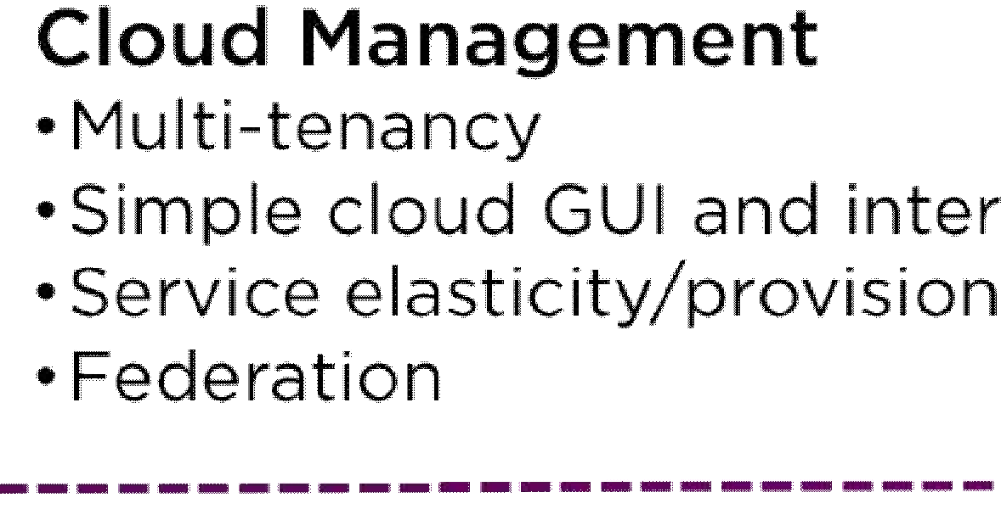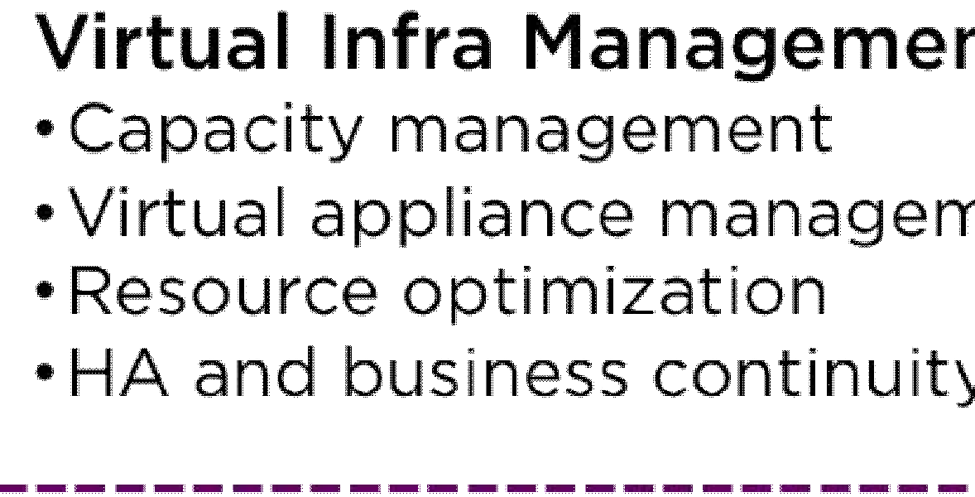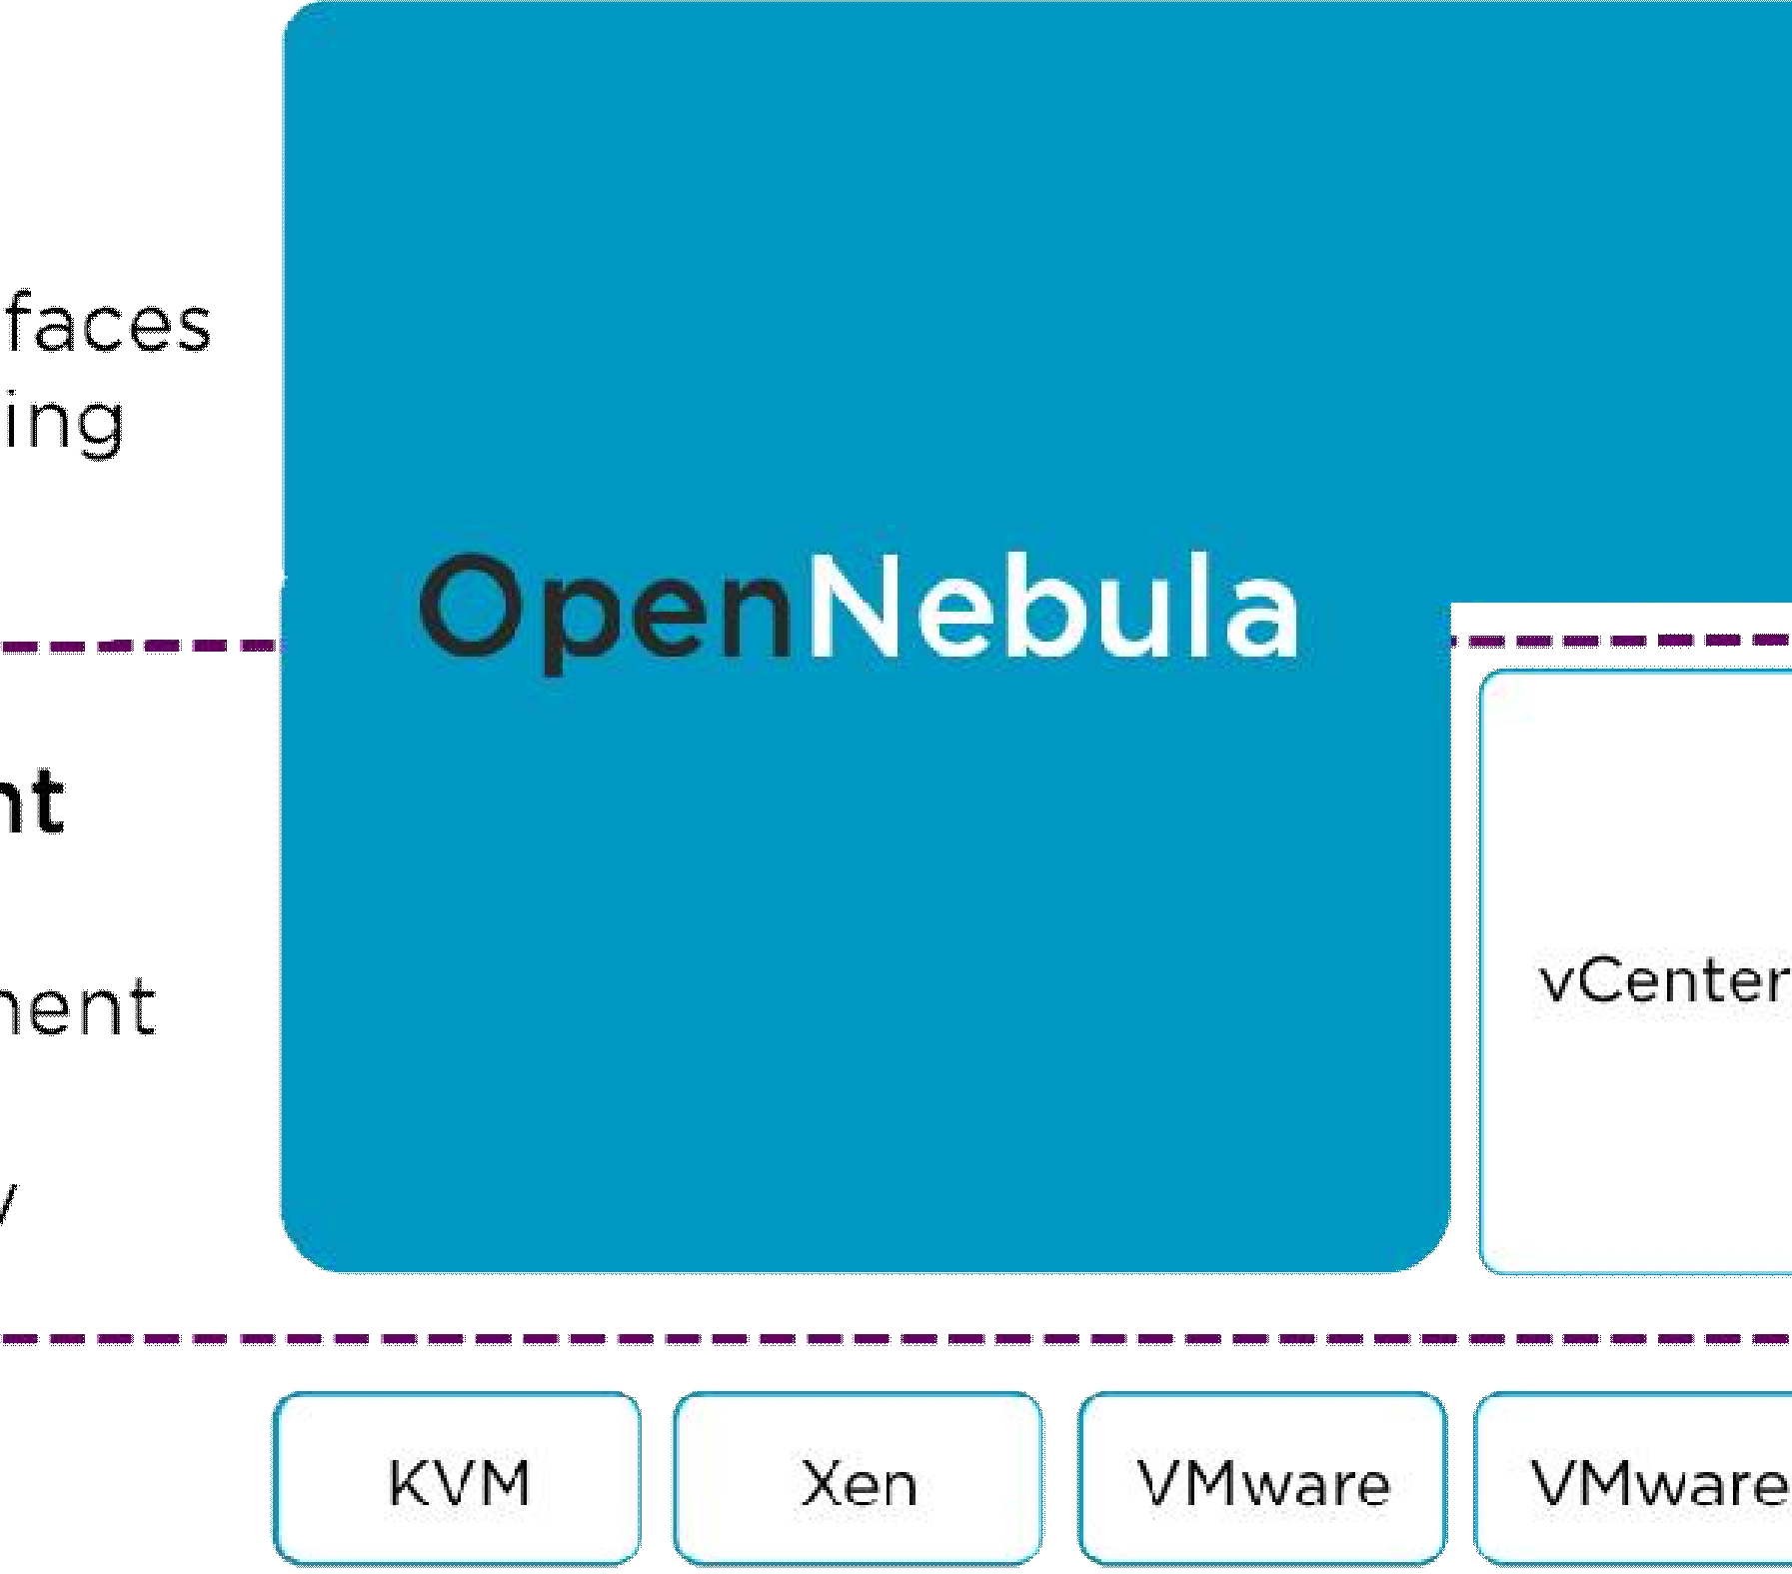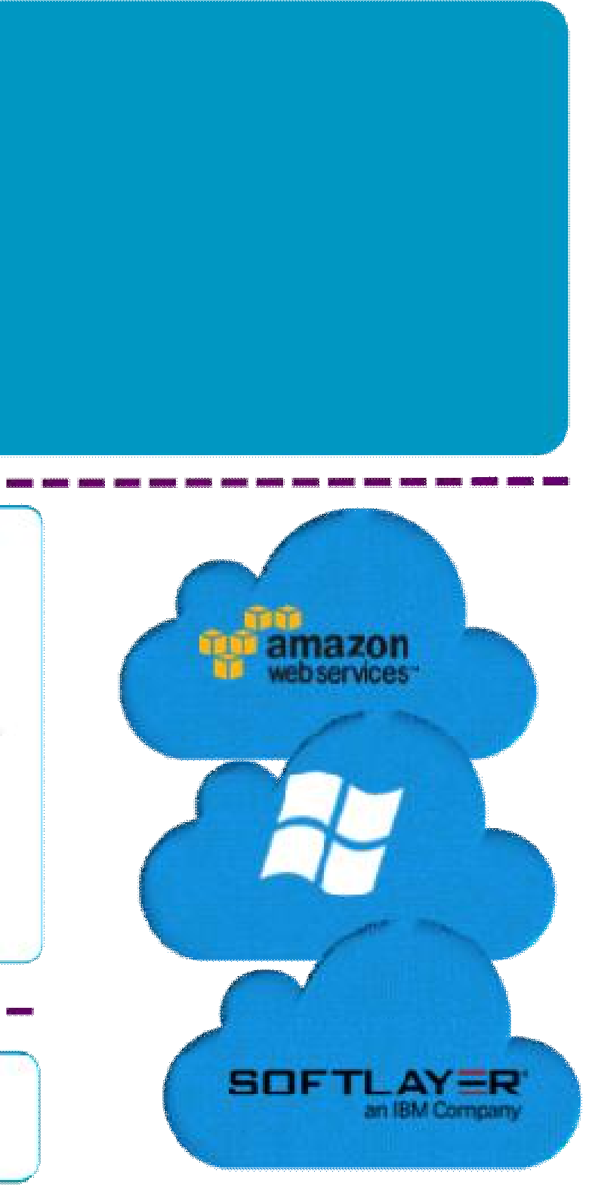The users who are looking for provisioning, elasticity and multi-tenancy cloud features like virtual data centers provisioning, datacenter federation or hybrid cloud computing to connect in- house infrastructures with public clouds, while the infrastructure is managed by already familiar tools for infrastructure management and operation.

What are Design Principles?
The OpenNebula technology is the result of many years of research and development in efficient and scalable management of virtual machines on large-scale distributed infrastructures. OpenNebula was designed to address the requirements of business use cases from leading companies and across multiple industries, such as Hosting, Telecom, e-Government, Utility Computing etc.
The principles that have guided the design of OpenNebula are:
- Openness of the architecture, interfaces, and code
- Flexibility to fit into any datacenter
- Interoperability and portability to prevent vendor lock-in
- Stability for use in production enterprise-class environments
- Scalability for large scale infrastructures
- SysAdmin-centrism with complete control over the cloud
- Simplicity, easy to deploy, operate and use
- Lightness for high efficiency

What Are Its Benefits?

For the Infrastructure Manager

- Faster respond to infrastructure needs for services with dynamic resizing of the physical infrastructure by adding new hosts, and dynamic cluster partitioning to meet capacity requirements of services
- Centralized management of all the virtual and physical distributed infrastructure

- Higher utilization of existing resources with the creation of a infrastructure incorporating the heterogeneous resources in the data center, and infrastructure sharing between different departments managing their own production clusters, so removing application silos
- Operational saving with server consolidation to a reduced number of physical systems, so reducing space, administration effort, power and cooling requirements
- Lower infrastructure expenses with the combination of local and remote Cloud resources, so
eliminating the over-purchase of systems to meet peaks demands

For the Infrastructure User

- Faster delivery and scalability of services to meet dynamic demands of service end-users.
- Support for heterogeneous execution environments with multiple, even conflicting, software requirements on the same shared infrastructure.
- Full control of the lifecycle of virtualized services management.

For System Integrators

- Fits into any existing data center - its open, flexible and extensible interfaces, architecture and components

Builds any type of Cloud deployment
- Open source software, Apache license
- Seamless integration with any product and service in the virtualization/cloud ecosystem and management tool in the data center, such as cloud providers, VM managers, virtual image managers, service managers, management tools, schedulers.

Eucalyptus
Eucalyptus is paid and open-source computer software for building Amazon Web Services (AWS)-compatible private and hybrid cloud computing environments marketed by the company Eucalyptus Systems.
- Eucalyptus is the acronym for Elastic Utility Computing Architecture for Linking Your Programs To Useful Systems.
- Eucalyptus enables pooling compute, storage, and network resources that can be dynamically scaled up or down as application workloads change. Eucalyptus Systems announced a formal agreement with AWS in March 2012 to maintain compatibility.
- In September 2014, Eucalyptus was acquired by Hewlett-Packard.

Software architecture
Eucalyptus commands can manage either Amazon or Eucalyptus instances. Users can also move instances between a Eucalyptus private cloud and the Amazon Elastic Compute Cloud to create a hybrid cloud. Hardware virtualization isolates applications from computer hardware details.
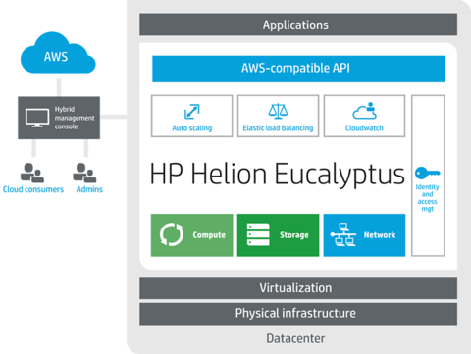
Eucalyptus architecture overview

Eucalyptus uses the terminology:
- Images – An image is a fixed collection of software modules, system software, application software, and configuration information that is started from a known baseline (immutable/fixed). When bundled and uploaded to the Eucalyptus cloud, this becomes a Eucalyptus machine image (EMI).
- Instances – When an image is put to use, it is called an instance. The configuration is executed at runtime, and the Cloud Controller decides where the image will run, and storage and networking is attached to meet resource needs.
- IP addressing – Eucalyptus instances can have public and private IP addresses. An IP address is assigned to an instance when the instance is created from an image. For instances that require a persistent IP address, such as a web-server, Eucalyptus supplies elastic IP addresses. These are pre-allocated by the Eucalyptus cloud and can be reassigned to a running instance.
- Security – TCP/IP security groups share a common set of firewall rules. This is a mechanism to firewall off an instance using IP address and port block/allow functionality. Instances are isolated at TCP/IP layer 2. If this were not present, a user could manipulate the networking of instances and gain access to neighboring instances violating the basic cloud tenet of instance isolation and separation.
- Networking – There are three networking modes.
- In Managed Mode Eucalyptus manages a local network of instances, including security groups and IP addresses.
- In System Mode, Eucalyptus assigns a MAC address and attaches the instance's network interface to the physical network through the Node Controller's bridge. System Mode does not offer elastic IP addresses, security groups, or VM isolation.
- In Static Mode, Eucalyptus assigns IP addresses to instances. Static Mode does not offer elastic IPs, security groups, or VM isolation.
- Access Control – A user of Eucalyptus is assigned an identity, and identities can be grouped together for access control.

Components
Eucalyptus has six components:
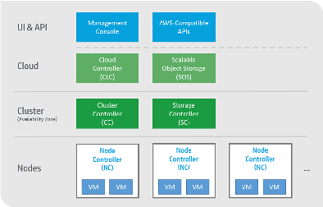

Eucalyptus components
- The Cloud Controller (CLC) is a Java program that offers EC2(Elastic compute cloud)-compatible interfaces, as well as a web interface to the outside world. In addition to handling incoming requests, the CLC acts as the administrative interface for cloud management and performs high-level resource scheduling and system accounting. The CLC accepts user API requests from command-line interfaces like euca2ools or GUI-based tools like the Eucalyptus User Console and manages the underlying compute, storage, and network resources. Only one CLC can exist per cloud and it handles authentication, accounting, reporting, and quota management.
- Walrus, also written in Java, is the Eucalyptus equivalent to AWS Simple Storage Service (S3). Walrus offers persistent storage to all of the virtual machines in the Eucalyptus cloud and can be used as a simple HTTP put/get storage as a service solution. There are no data type restrictions for Walrus, and it can contain images (i.e., the building blocks used to launch virtual machines), volume snapshots (i.e., point-in-time copies), and application data. Only one Walrus can exist per cloud.
- The Cluster Controller (CC) is written in C and acts as the front end for a cluster within a Eucalyptus cloud and communicates with the Storage Controller and Node Controller. It manages instance (i.e., virtual machines) execution and Service Level Agreements (SLAs) per cluster.
- The Storage Controller (SC) is written in Java and is the Eucalyptus equivalent to AWS EBS( Elastic Block Store) . It communicates with the Cluster Controller and Node Controller and manages Eucalyptus block volumes and snapshots to the instances within its specific cluster. If an instance requires writing persistent data to memory outside of the cluster, it would need to write to Walrus, which is available to any instance in any cluster.
- The VMware Broker is an optional component that provides an AWS-compatible interface for VMware environments and physically runs on the Cluster Controller. The VMware Broker overlays existing ESX/ESXi hosts and transforms Eucalyptus Machine Images (EMIs) to VMware virtual disks. The VMware Broker mediates interactions between the Cluster Controller and VMware and can connect directly to either ESX/ESXi hosts or to vCenter Server.
- The Node Controller (NC) is written in C and hosts the virtual machine instances and manages the virtual network endpoints. It downloads and caches images from Walrus as well as creates and caches instances. While there is no theoretical limit to the number of Node Controllers per cluster, performance limits do exist.

Amazon Web Services compatibility
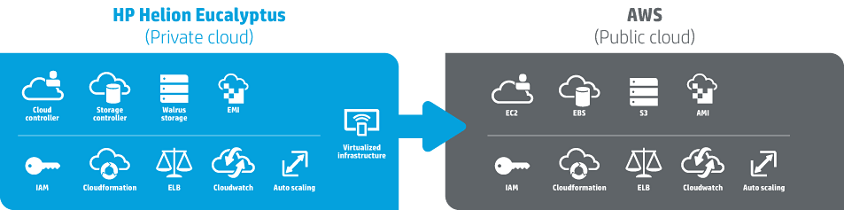
Eucalyptus Compatibility with Amazon Web Services
Organizations can use or reuse AWS-compatible tools, images, and scripts to manage their own on-premises infrastructure as a service (IaaS) environments. The AWS API is implemented on top of Eucalyptus, so tools in the cloud ecosystem that can communicate with AWS can use the same API with Eucalyptus. In March 2012, Amazon Web Services and Eucalyptus announced details of the compatibility between AWS and Eucalyptus. As part of this agreement, AWS will support Eucalyptus as they continue to extend compatibility with AWS APIs and customer use cases. Customers can run applications in their existing data centers that are compatible with Amazon Web Services such as Amazon Elastic Compute Cloud (EC2) and Amazon Simple Storage Service (S3).
In June, 2013, Eucalyptus 3.3 was released, featuring a new series of AWS-compatible tools. These include:
- Autoscaling – Allows application developers to scale Eucalyptus cloud resources up or down in order to maintain performance and meet SLAs. With auto-scaling, developers can add instances and virtual machines as traffic demands increase. Auto-scaling policies for Eucalyptus are defined using Amazon EC2-compatible APIs and tools.
- Elastic Load Balancing – A service that distributes incoming application traffic and service calls across multiple Eucalyptus workload instances, providing greater application fault tolerance.
- CloudWatch – A monitoring tool similar to Amazon CloudWatch that monitors resources and applications on Eucalyptus clouds. Using CloudWatch, application developers and cloud administrators can program the collection of metrics, set alarms and identify trends that may be endangering workload operations, and take action to ensure their applications continue to run smoothly.
Eucalyptus 3.3 is also the first private cloud platform to support Netflix's open source tools – including Chaos Monkey, Asgard, and Edda – through its API fidelity with AWS.

Functionality
- The Eucalyptus User Console provides an interface for users to self-service provision and configure compute, network, and storage resources. Development and test teams can manage virtual instances using built-in key management and encryption capabilities. Access to virtual instances is available using familiar SSH and RDP mechanisms. Virtual instances with application configuration can be stopped and restarted using encrypted boot from EBS capability.
- IaaS service components Cloud Controller, Cluster Controller, Walrus, Storage Controller, and VMware Broker are configurable as redundant systems that are resilient to multiple types of failures. Management state of the cloud machine is preserved and reverted to normal operating conditions in the event of a hardware or software failure.
- Eucalyptus can run multiple versions of Windows and Linux virtual machine images. Users can build a library of Eucalyptus Machine Images (EMIs) with application metadata that are decoupled from infrastructure details to allow them to run on Eucalyptus clouds. Amazon Machine Images are also compatible with Eucalyptus clouds. VMware Images and vApps can be converted to run on Eucalyptus clouds and AWS public clouds.
- Eucalyptus user identity management can be integrated with existing Microsoft Active Directory or LDAP systems to have fine-grained role based access control over cloud resources.
- Eucalyptus supports storage area network devices to take advantage of storage arrays to improve performance and reliability. Eucalyptus Machine Images can be backed by EBS-like persistent storage volumes, improving the performance of image launch time and enabling fully persistent virtual machine instances. Eucalyptus also supports direct-attached storage.
- Eucalyptus 3.3 offers new features for AWS compatibility. These include resource tagging, which allows application developers and cloud administrators to assign customizable metadata tags to resources such as firewalls, load balancers, Web servers, and individual workloads to better identify them. Eucalyptus 3.3 also supports an expanded set of instance types to more closely align to instance types in Amazon EC2.
- Eucalyptus 3.3 also includes a new Maintenance Mode that allows cloud administrators to perform maintenance on Eucalyptus clouds with zero downtime to instances or cloud applications. It also includes new user console features such as a Magic Search Bar, and an easy option to allow users to change their password.
- Eucalyptus 3.4, released on October 24, 2013, added new features including improved image management and migration tools, capabilities for warm upgrades, a hybrid cloud user console to manage both Eucalyptus and AWS resources, Identity and Access Management (IAM) roles, and improved High Availability (HA) capabilities
Web based communication tools
In today's digital era, communication is easier than ever before. People can connect with each other, share online content with the click of a button and work together on projects regardless of distance. Modern communication devices, such as smartphones and laptops, open up new opportunities for individuals and businesses alike.
Communication tools can include:
- smartphones
- laptops
- tablets
- VOIP/Internet telephony
- intranet
- social networks
- forums
- messenger apps
- chatbots
- email
- blogs
- tracking software
Employees can now work remotely and attend meetings without having to leave home. Business owners can hold conferences online, close deals and invoice customers on the go. Modern technology allows for real-time communication and information exchange leading to more efficient business operations.

Smartphones
More than 80 percent of internet users’ own smartphones. The number of smartphone users worldwide is expected to reach 2.5 billion by 2019. Depending on your industry, any of them could be a potential customer.
These communication devices boast cutting-edge features, such as GPS navigation, voice-activated virtual assistants, predictive typing and video calling. Users can download apps that further enhance their mobile experience. They can scan QR codes with their smartphones, pay their bills on the go and check the stock market in real time.

Tablets
Over 30 percent of U.S. households own at least one tablet. Some use these modern communication tools for work. Others watch movies, access social media and make video calls on their tablets. Due to their compact design, these devices can replace your laptop or computer. They're portable and have all the functionalities of a smartphone and more.

If you're a business owner, it's important to target customers across all devices and channels. Your website needs to be responsive and provide a seamless mobile experience. The same goes for your advertising campaigns, which need to be customized for each device so you can target the right audience in the right context.

Laptops
The demand for laptop computers has decreased over the last few years. In 2015, only 78 percent of Americans under 30 owned a laptop or desktop PC, compared to 88 percent who did so in 2010. Today, these communication tools are used mostly for work.

However, laptops have some advantages over smartphones and tablets. Let's take software development. Even though you can design an app or a website on your tablet, it's easier to do in on a laptop or desktop computer.

If you're a blogger or copywriter, doing your work on a tablet can be difficult. The small screen may cause eyestrain and affect your productivity. Additionally, laptops have a larger storage capacity compared to smartphones and tablets, letting you save large files and access them with ease.

VoIP and Internet Telephony
Nowadays, more and more organizations are carrying voice communications over the internet. They use Skype and other platforms to interview potential employees, hold video conferences and make international calls. These communication modes are cheaper and more convenient than traditional phone services.

VoIP (Voice over Internet Protocol), has emerged as one of the most popular communication tools worldwide. Small businesses can save as much as 75 percent on local calls by switching to VoIP. Higher productivity, greater flexibility and more efficient message management are just a few of the benefits linked to this service.

Intranet
An intranet is a private network that can be accessed by authorized users within an organization. Companies use an intranet to streamline communication between employees, share documents and keep them up-to-date with the latest industry news. This technology ensures everyone is on the same page, allowing for more efficient collaboration.

Social Networks and Forums
Social media is widely used by individuals and corporations worldwide. It has the power to drive business decisions, increase brand awareness and connect customers with their favorite brands. It's also one of the most important communication tools, making it easier for brands to reach their target audience and get their message across.

Companies can harness the power of social media to strengthen their online presence and improve customer experience. For example, customers leave valuable feedback on your Facebook business page. Here you can address their concerns and get better insights into your audience.

Forums can be a valuable communication tool. As a business owner, you can use these platforms to learn more about your customers' needs and wants. You can also reply to their questions, recommend products and find ideas for your marketing campaigns.

These are just a few of many communication tools available today. Messenger apps, chatbots, email, internal blogs and tracking software are also useful and often essential communication tools. Businesses can leverage modern technology to attract and engage customers, address their inquiries and deliver a superior experience across all devices.

Best Communication Tools for 2020

- Blink
- Ryver
- ZohoCliq
- Fleep
- Slenke
- Flock
- Microsoft Teams
- Rocket Chat
- Workplace
- Teamwork Chat

There are several tools which can be easily and successfully utilized in an online setting to both collaborate and communicate. Most of these online communication tools for business are only utilized in real-time settings. This is why they heavily depend on various media such as auditory and visual, can be faced with numerous accessibility barriers and might have complex interfaces.
The different types of online communication tools are as listed below:

Video conferencing
Video conferencing services have developed to become one of the top types of online communication tools. Businesses benefit from video conferencing through meetings. This is because meetings allow for the discussion of business progress and the collaboration of ideas. Video conferencing software such as ezTalks Cloud Meeting allows for arrangement of meetings regardless of the physical location of a member thus good for emergency cases. This means that video conferencing guarantees a speedy redress of business concerns and increased productivity. Effective online communication tools for business like video conferencing has the following benefits:

●It enables immediate meetings and short notice meetings.
●It facilitates collaboration without an individual having to leave their office.
●It is very cost-effective.
●It allows for multi-point meetings based on various time zones.
●It allows for real-time concessions.
●It facilitates non-verbal communication.
Video conferencing software such as ezTalks Cloud Meeting only needs the user to have a camera and a microphone so as to communicate online.

Chats
Chats can be described as online text conversations that happen in real-time. The 3 ways of conducting chats include the following:
●Internet relay chat – Users of IRC employ an external program (a client) in order to create a connection with an IRC server. This means that the accessibility of an IRC mainly relies on the client’s accessibility. This tool is mostly used by a technical audience.
●Instant messenger – This is a downloadable messaging program that people use to communicate. Examples of messenger include AOL Instant Messenger and MSN Messenger. Instant messaging has become a more reliable online communication tools for students, especially with the latest generation. Instant messenger software usually requires users to create a nickname and an account. Communicators are heavily used to facilitate private chats, this is in different forms like phone services, file and video exchange and of course messaging.
●Web-based chat – These are online chats which are accessed via a normal browser. A good example is the chat feature that Gmail has put in place. Usually, a portion of the screen or even the entire screen refreshes on a regular basis. Web-based chats are very accessible today because the output is HTML.

Whiteboards
Interactive whiteboards are among the most recent types of online communication tools. Whiteboards are popular online communication tools in education. They are beneficial as they allow users to write, draw and even collaborate with the help of an interface which simulates an actual physical whiteboard.
Whiteboards require users to have a mouse in order to add some content. Most, if not all the content in an electronic whiteboard is created in real-time and graphical. Whiteboards have become the top online communication tools in education because of their features aid in learning.

Forums
There are several ways by which online forums are referred to as, these are discussion groups, discussion boards, bulletin boards and just forums. They can be described as places where all users are allowed to post either comments or post questions. Other users of the forums are permitted to post replies to posts so as to create a kind of online discussion. The posts from the discussion are properly stored to be chronologically sorted out in a bid to form threads.
These online forums are all keyboard accessible. Avatars, emoticons and images all require alt text that is appropriate. Forums as online communication tools utilize inaccessible CAPTCHAs for registration, these function to keep out spammers and bots. Forums are insightful online communication tools in education as they contain a lot of valuable information.

Voice over IP
Voice over IP also known as VoIP is a term that is used in reference to a voice conversation which is conducted over an internet connection rather than over the traditional phone line. Various large organizations utilize VoIP in place of the conventional phone line. It should be noted that it is very possible to make Voice over IP calls over a computer but with either handsets or a USB headset. VoIP calls are purely audio-based. Some good example of VoIP as an online communication tools for business are Skype, ezTalks, Whats App, etc.

Email
Electronic mail or email is among the old online communication tools. It allows users to transfer photographs, send files and receive news from any part of the world. This online communication tool is broadly utilized for public communication, particularly in mailing lists.
The list above is not exhaustive as there are other basic online communication tools such as websites, newsletters, web 2.0 and even social networks.
The internet has availed a good number of new mainstream communication tools that has revolutionized things. This is because the different types of online communication tools have greatly reduced the time spent in creating and delivering messages.

